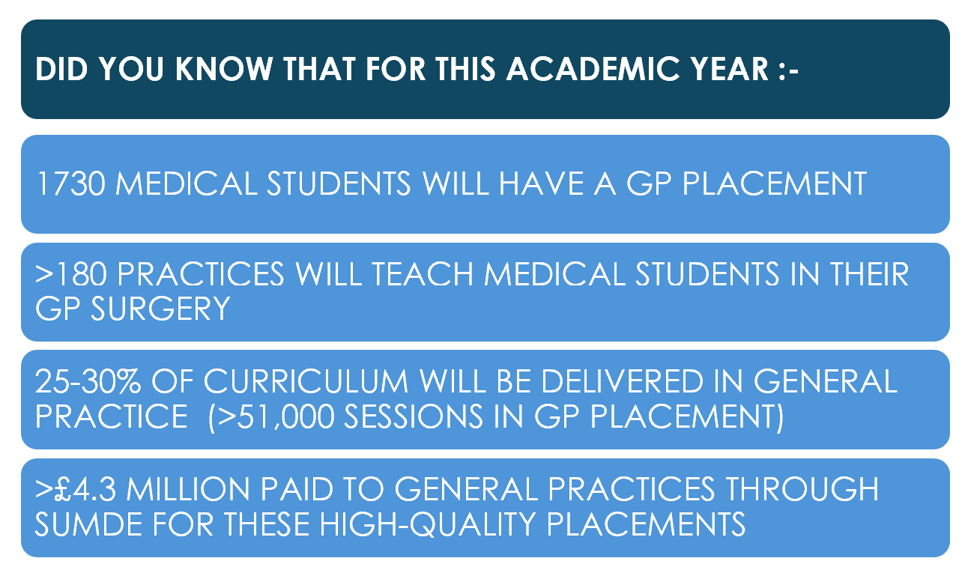
The start of a new academic year

In our second newsletter, we want to share with you how we are supporting practices, as well as enhancing medical student placements from a GP perspective. We recognise that General Practice teams in Northern Ireland are currently working extremely hard to deliver safe, high quality patient care against a backdrop of collective action!


Team News
We are delighted to welcome Dr Paula Houton as an Eastern Locality Lead (LL). We look forward to introducing our new Western LL (starting soon) in the next newsletter.
Our QUB Module Leads (MLs) are now facilitating the small group learning sessions for years 4 and 5, as well as supporting students in those year groups with MyProgress, and other GP related activities. They will be speaking to the students about their time on placement and may be in contact with practices if there are queries. You can contact them at admin@gpsubdeanery.co.uk
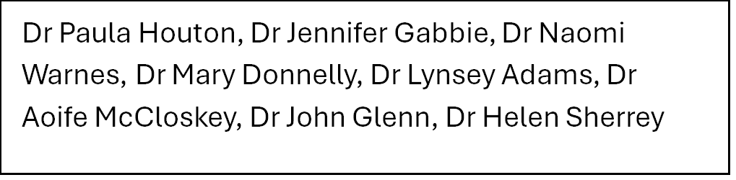
Our 3 new Ulster University MLs started at the end of September 2025, joining Dr Laura Devine (already in this role). We look forward to sharing a photo and update on their work in our next newsletter.

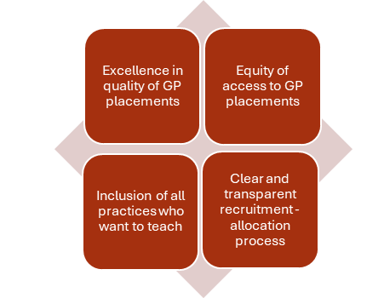
Our focus in the coming months will be on finishing the review of the existing allocation processes for both medical schools with a view to devising guiding principles for future recruitment. We want to hear from all practices, both teaching and non-teaching, so look out for our email in the coming weeks. You can see our key values in this diagram.

Website - www.gpsubdeanery.co.uk

Our website has proved a great resource for practices. We welcome ideas for new content. It is also the easiest way to get in touch if you have any queries. Simply click on the CONTACT Tab on the Homepage. You can also email admin@gpsubdeanery.co.uk

Calling all rural practices!


The GP Sub Deanery is keen to hear from rural practices, both teaching and non-teaching. We want to understand how geography impacts on recruitment and retention of the GP workforce, and potentially the ability to host medical students.
The GP Sub Deanery is actively exploring ways to ensure teaching is accessible to every practice irrespective of where they are located. Any information shared with us will be used to develop our policies and be held in strictest confidence.

CP2A for teaching medical students

From 1st September 2025 you should request a CP2A form for your role as a GP Tutor via the GP Sub Deanery website. For any other roles such as OSCE examiner, clinical teaching in the medical school, or interviews, the CP2A should be requested from the relevant medical school. More information is available on our QUALITY ASSURANCE Tab on our website.
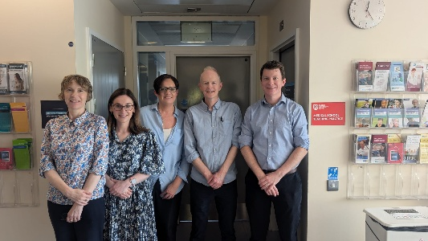

Practice Visits

We have now completed close to 100 practice visits across all GP Federations. Both medical schools have shared with us their anonymised student feedback for 2024-25 (in the format each practice received it).
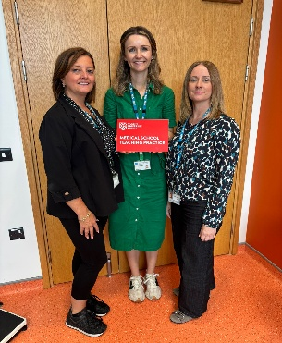
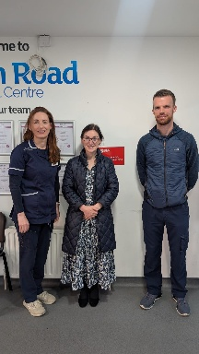
It is great to see that practices are continuing to deliver consistently high-quality placements. Where possible we have discussed this individual practice feedback during visits. We are keen to ensure that the feedback you receive is timely, and in a format that is easy to understand.

IT Issues affecting Teaching Practices

It is essential that medical students have access to the GP clinical system when on placement to ensure they meet their learning objectives. Unfortunately, the rollout by BSO of a new “VDI cloud server” to practices across NI (which commenced in August 2025) has resulted in a small number of practices being unable to provide students with access to the clinical system. We know 12 practices have been affected to date (30th September), and the number will slowly rise in the coming months.
We have attempted to contact all affected practices to offer support and have been working with both medical schools and BSO to find an urgent solution. We have asked medical schools to notify students. If your practice has been affected and you have not yet spoken to us, please get in touch to discuss your situation.

